Leclou,Dennis D.W.



Names: Fee van Zoghel, Dennis Leclou,
Matthijs van Meeuwen and Bas Wensing
Teachers: Roy Willemen & Lonneke Driessen
Client: Esra-Sayiner Gürler (Transdev)
Subject: Project 5
Project Group: 5
Justification rEport
Project 5, Group 5
Contents
Pseudocode 2
The algorithm in a nutshell 2
Functions 2
Parameters 2
Comparison of original versus improved bus plan 5
Performance indicators comparison 5
Feasibility comparison 5
Conclusion 6
References 9

Pseudocode

The algorithm in a nutshell
The pseudocode describes our ‘greedy’ algorithm for generating an improved bus schedule. The algorithm processes all service trips in chronological order and checks whether an existing bus can complete each trip while meeting the time, location, and battery constraints. If multiple buses are available, the bus whose last activity ended most recently is selected. If no suitable bus is available, a new bus is added. The algorithm also considers charging, material trips, and idle time. After all service trips have been assigned, the buses return to the garage and are charged to 100%.

Functions
Table 1
Functions and descriptions of the pseudocode.

Function | Description
Add_Activity | Adds a service trip, material trip, idle period, or charging activity to the bus schedule.
Check_Material_Trip | Calculates the travel time and energy consumption from the current location to the starting location of the next trip. Can also add the material trip to the schedule.
Calculate_Idle_Time | Calculates the idle time and corresponding energy consumption. Can also add the idle period to the schedule.
Check_Charging_Buses | Checks whether buses need to charge, calculates the possible charging duration, and determines whether they are available afterwards.
Garage_To_Trip | Adds a material trip from the garage to the starting location of a trip for a new bus, if necessary.

Most functions are briefly described in Table 1. However, the Check_Charging_Buses function (Figure 1) is explained separately in more detail because it contains several complex decisions and conditions that affect the bus planning.
The functions listed in Table 1 are referenced throughout the pseudocode (Figure 2). To distinguish them from the other steps, all function names are written in italics.

Parameters
The algorithm assumes a nominal battery capacity of 300 kWh and a State of Health (SOH) of 85%, resulting in an effective battery capacity of 255 kWh. Therefore, a battery level of 100% corresponds to 255 kWh.
A minimum battery level of 10% must be maintained. Charging is performed at 450 kW up to 90% of the effective battery capacity, after which the charging power decreases to 60 kW until the battery reaches 100%. The minimum charging duration is 15 minutes.
The parameters can be adjusted to different values without changing the underlying logic of the algorithm. This allows the algorithm to be applied to different situations and requirements.
Figure 1
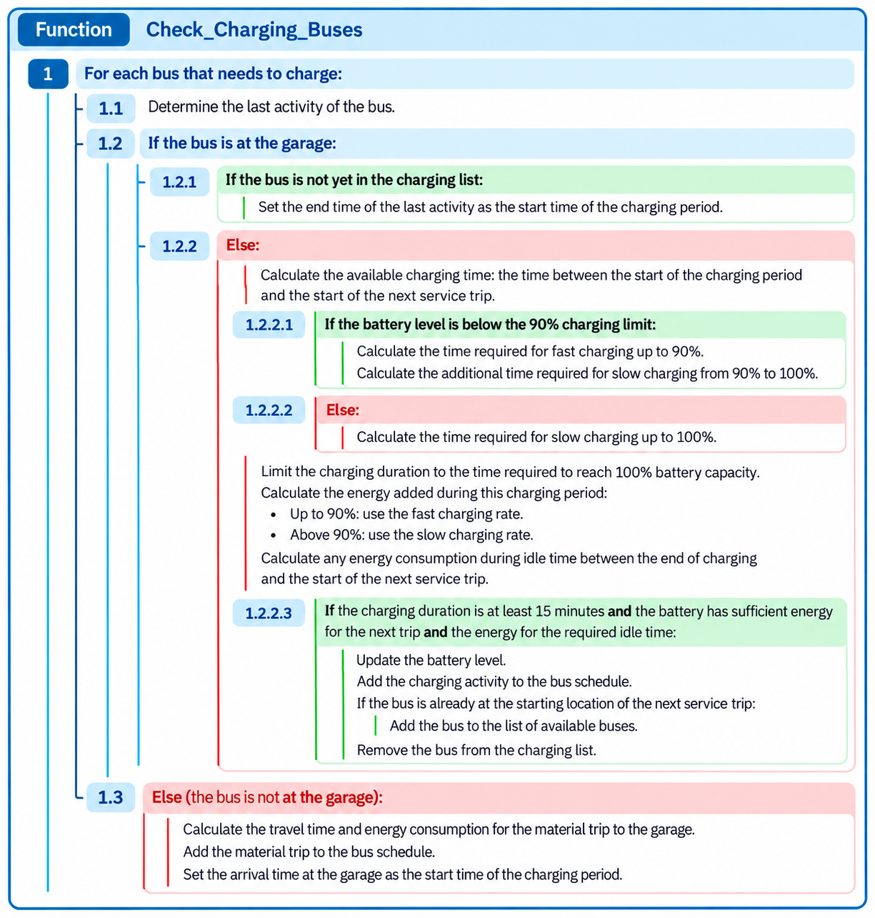
Pseudocode of the ‘Check_Charging_Buses’ function.
Note: the pseudocode was developed by the authors. ChatGPT (OpenAI, 2026) was used to create the visual layout.

Figure 2
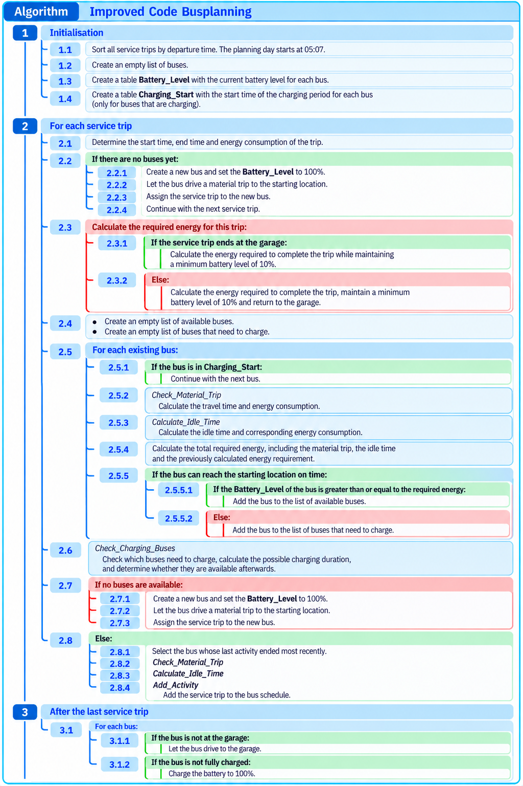
Pseudocode of the improved code.

Note: the pseudocode was developed by the authors. ChatGPT (OpenAI, 2026) was used to create the visual layout.

Comparison of original versus improved bus plan

Performance indicators comparison
The quality of a bus plan is not only determined by the feasibility of the scheme, but also by the predefined Key Performance Indicators (KPIs). These include (from most to least important): total number of buses used, average waiting time per bus, total material trips, charging time and energy consumption (Figure 5). All of these performance indicators should be kept as low as possible, and we mainly focused on the first three. Reducing the number of buses and material trips also logically leads to lower total energy consumption. For calculating the KPI values, an average energy estimation for all trips and a SOH value of 85% are taken into account.
When comparing the KPI values of the original bus plan with those of the improved plan, the largest improvement can be seen in the number of material trips. This performance indicator has been decreased by 79.7%, from 251 to 51 trips (Figure 5). This reduction is also clearly visible when comparing the bus schedules in Figure 3 and Figure 4. The total energy consumption (-37.0%) and the number of buses (-25.0%, from 20 to 15 buses) have also been decreased significantly, with the number of buses being the most important KPI. When minimum travel times are used instead of average travel times, the improved plan requires only 14 buses.
However, total charging time (+78.0%) and especially average waiting time per bus (+284.0%) have been increased significantly. The average waiting time per bus has almost been quadrupled, from 38.75 to 148.79 minutes (Figure 5). The total waiting time has been increased by 188.0%, which is partly explained by the reduced number of buses. It should be noted that not all idle periods were registered as idle time in the original bus plan, which may affect the comparison of waiting times. Furthermore, the improved plan contains significantly fewer material trips, which contributes to longer waiting times between service trips.
The total charging time has been increased by 78.0%, because all buses are fully charged at the end of each day. The final 10% of the battery capacity is charged at a slower charging rate of 60 kW instead of 450 kW, which results in a longer total charging time.

Feasibility comparison
Besides comparing the KPI values, the feasibility of both bus plans was evaluated using the predefined feasibility criteria. These include all required service trips, no overlapping trips, matching start and end location, SOH, minimum charging time, charging speed and minimum State of Charge (SOC). The comparison is presented in Table 2. It shows that the improved bus plan meets all feasibility criteria, while the original bus plan fails to meet several of those criteria.

Table 2
Comparison feasibility criteria.

Conclusion
In conclusion, three out of five KPIs have improved compared to the original bus plan. Using an average energy estimation and a SOH value of 85%, the most important KPI, the number of buses, has been reduced by 25.0%. Furthermore, the number of material trips and total energy consumption have been decreased significantly, by 79.7% and 37.0%, respectively.
However, average waiting time per bus and total charging time have been increased by 284.0% and 78.0%, respectively. The increase in waiting time can partly be explained by the fact that not all idle periods were registered in the original bus plan and a reduction of the material trips. The increase in charging time is mainly caused by fully charging all buses at the end of the day.
Furthermore, the improved bus plan meets all feasibility criteria, while the original bus plan fails to meet several of those criteria.
Overall, the improved bus plan significantly reduces the number of buses, material trips and total energy consumption while meeting all feasibility criteria, despite not improving every KPI. Therefore, the main objective of Transdev has been achieved.

Figure 3
Bus schedule for the original bus plan.
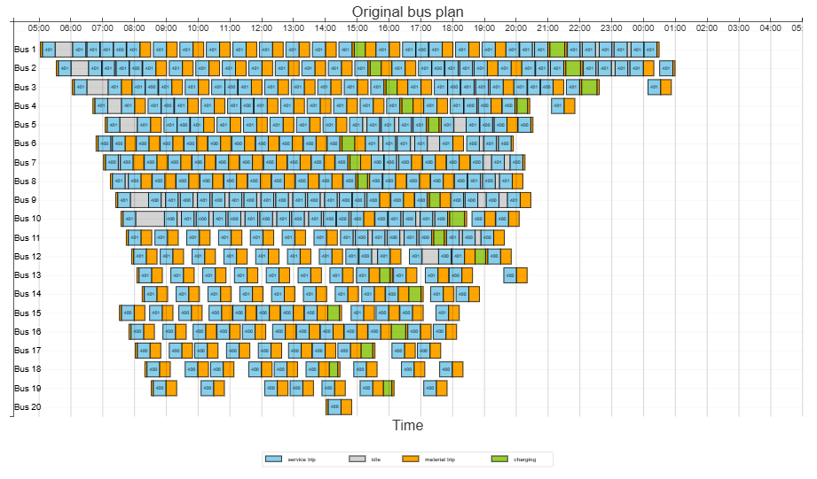
Figure 4
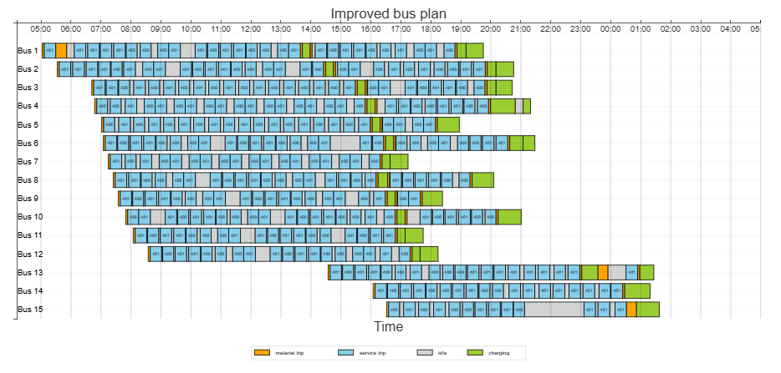
Bus schedule for the improved bus plan.

Figure 5
Calculated KPI values for original bus plan (left) and improved plan (right).
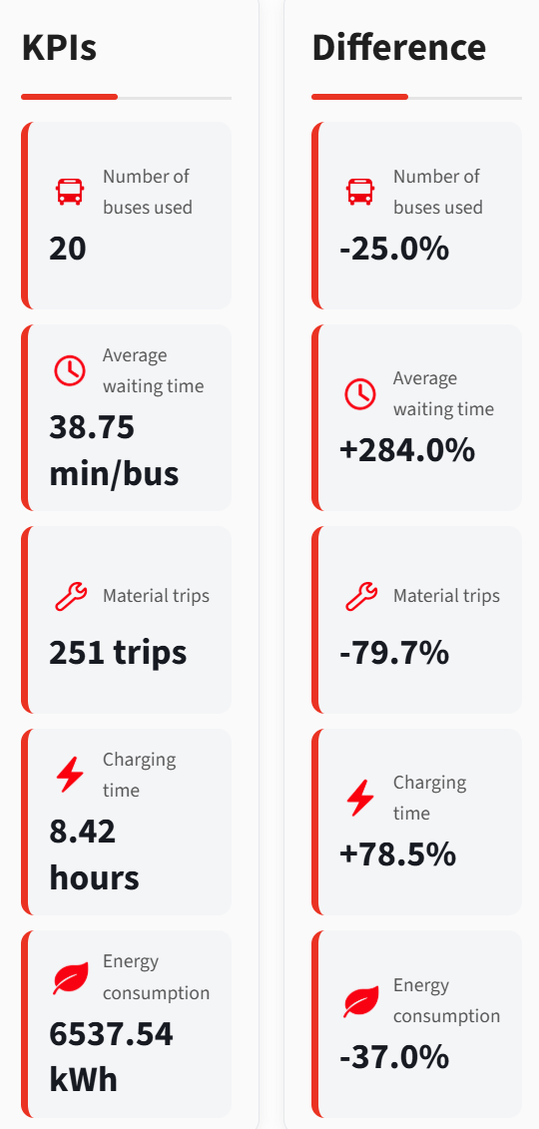
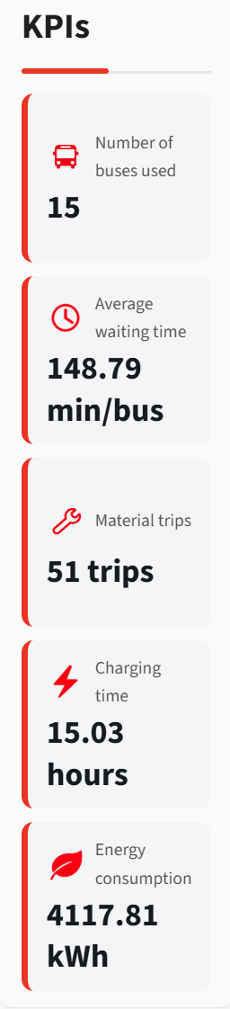

References
- OpenAI. (2026). ChatGPT [Large language model]. https://chatgpt.com/

